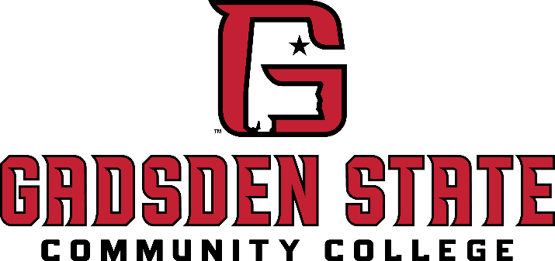
Save the Date or You’re Invited
EVENT TITLE
Month, Date & Year
Time

This special occasion will bring together esteemed dignitaries, valued stakeholders,
and community leaders as we [brief purpose of event, e.g., celebrate, recognize, launch, etc.].

Your presence would be an honor as we continue our commitment
to education, innovation, and community engagement.

EAST BROAD CAMPUS
Joe Ford Center | Room 201
501 East Cardinal Drive, Gadsden, AL 35903
Click to RSVP Today


